**BACKGROUND:**

* **For the CNN (Convolutional Neural Network) Task, the dataset selected was images of dogs and cats. This dataset is divided into two directories: Training and Testing. In the Python script, the Training dataset is split into training and validation for the model to learn. The model is then saved and loaded whenever a prediction has to be made. The predictions are made based on image input chosen at random from the Testing directory.**
* **The CNN model is scripted into the main chatbot code and if the command “LEARN” is passed to the chatbot, the model learns from the dataset.**

**CONVERSATION LOG:**

**Starts with general conversation. User then asks for a pet.**

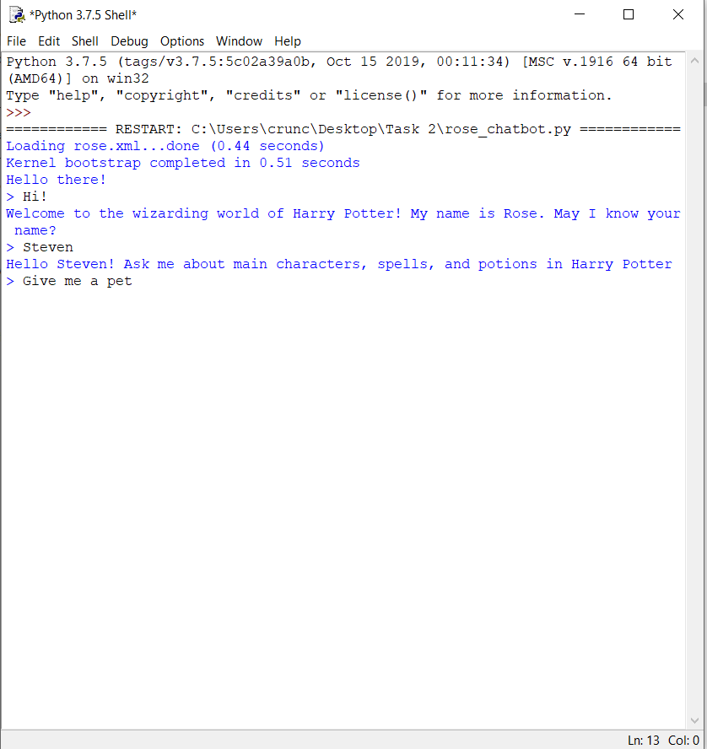

**An image is selected at random from the test data images and displayed to the user.**

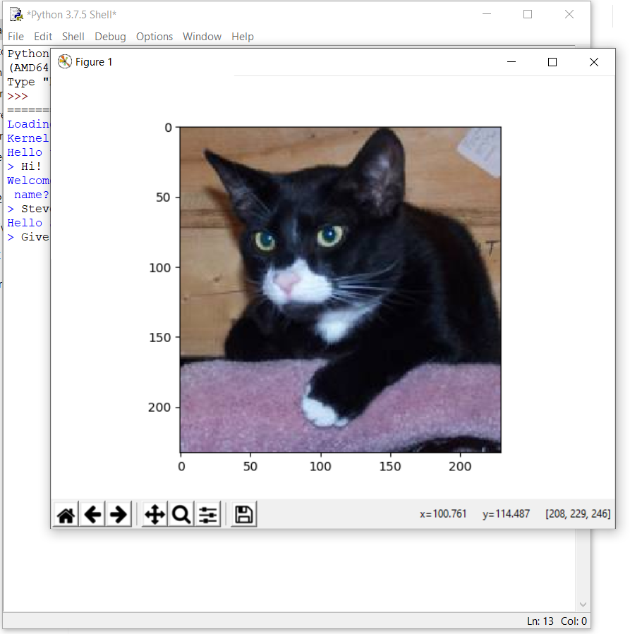

**User asks which animal their pet is. The chatbot categorises the animal based on the CNN model’s learning. In this case, the it correctly classifies the animal as a cat.**

